44 Vanderlin Dr Wagaman 0810 NT

0431510794

h102136@gmail.com

PeiHan, LinA long, thin rectangle to divide sections of the document

# I am PEI HAN, LIN, studying software engineering at Charles Darwin University. Passionate about software development practices, I actively participate in various programming-related courses and projects to continuously improve my skills in programming, and software testing. I am familiar with Python and have a basic understanding of software testing and data analysis.

# During my studies, I focused on learning software development. I have participated in an internship project, the project's purpose was to process a porting task that ports an S2 geometry library of Javascript version into Dart version, I have learned a lot in this project ex. git, docker, testing process, porting process, project structure, and readable coding. These experiences have given me an understanding of software development that I didn't learn in the university. I also actively participated online in software development skills and some techniques as a report writer, which not only expanded my technical knowledge but also exercised my problem-solving and skills in data analysis.

# I am keen on exploring new technologies and hope to use my knowledge in software development, data analysis, or related fields in the future to become a software engineer who can solve practical problems.

# 

# EDUCATION

A long, thin rectangle to divide sections of the document

Charles Darwin University, NT Australia

Master of Software Engineering

# Certification

A long, thin rectangle to divide sections of the document

SQL Essential Training

<https://lnkd.in/eWBAm73T>

<https://lnkd.in/eFSB92jR>

Learning SQL Programming

<https://lnkd.in/dSv9AKQF>

<https://lnkd.in/dsgCm4UF>

SQL: Data Reporting and Analysis

<https://lnkd.in/esC7tMhY>

SQL for Data Analysis

<https://lnkd.in/ejq_V7QR>

Power BI Essential Training

<https://lnkd.in/eMUqiJsk>

<https://lnkd.in/eRy_WVgd>

A long, thin rectangle to divide sections of the document

# SKILLS

A long, thin rectangle to divide sections of the document

**Software Developing**: Python(data analysis, testing, application development), Javascript (web development), Dart (Basic syntax)

**Data analysis**: Processing analysis with Python (NumPy, Pandas)

**Data Visualization**: Creating visualizations with Python (Matplotlib, Seaborn, and Plotly)

**Reporting**: using Power BI to create interactive dashboards and visual reports for data-driven decision-making.

# Tools

A long, thin rectangle to divide sections of the document

**Python**: Basic syntax, data analysis tools such as NumPy, Pandas, Matplotlib, Seaborn, and Plotly, model fitting

**Javascript:** full-stack developing experience

**Dart**: Basic syntax, the experience of a porting task by other programming language

**SQL**: Basic knowledge of query database

**Power BI service**: Data analysis, data visualization

**Power BI desktop:** Basic knowledge of data transformation

**Docker**: Basic knowledge with actual practice

**Testing tool**: Python (unittest), Dart(official testing tool), Coverage tool

# EXPERIENCE

A long, thin rectangle to divide sections of the document

**Relative:**

**Internship** (Company: Smart-Mind <https://www.smart-minds.io/en/>):

Developed a porting task that ports an S2 geometry library of Javascript version into Dart version, imported this package in a flutter demo project, uploaded the package on pub.dev as a open source

**Non-relative**

Star Track (Logistic): General Labour (2y)

Fedex (Logistic): General Labour (1y)

Nature’s Care (Health care production): General Labour (2y)

# Academic Project

A long, thin rectangle to divide sections of the document

**Hello World visualize projects**

**Tools**:

Power BI: An interactive data visualization tool from Microsoft

Tableau: A leading data visualization software known for its flexibility

Google Looker Studio: A cloud-based data visualization tool by Google

**Database**: Nigerian Traffic Crashes (2020-2024)

**Description:** This project involves visualizing data on Nigerian traffic crashes from 2020 using three different data visualization tools: Power BI, Tableau, and Google Looker Studio. The objective is to create intuitive, engaging, and insightful visualizations that present key findings, trends, and patterns within the dataset, using a simple dataset structure to convey meaningful insights about traffic incidents in Nigeria.

**Outcome:**

**Power BI:**

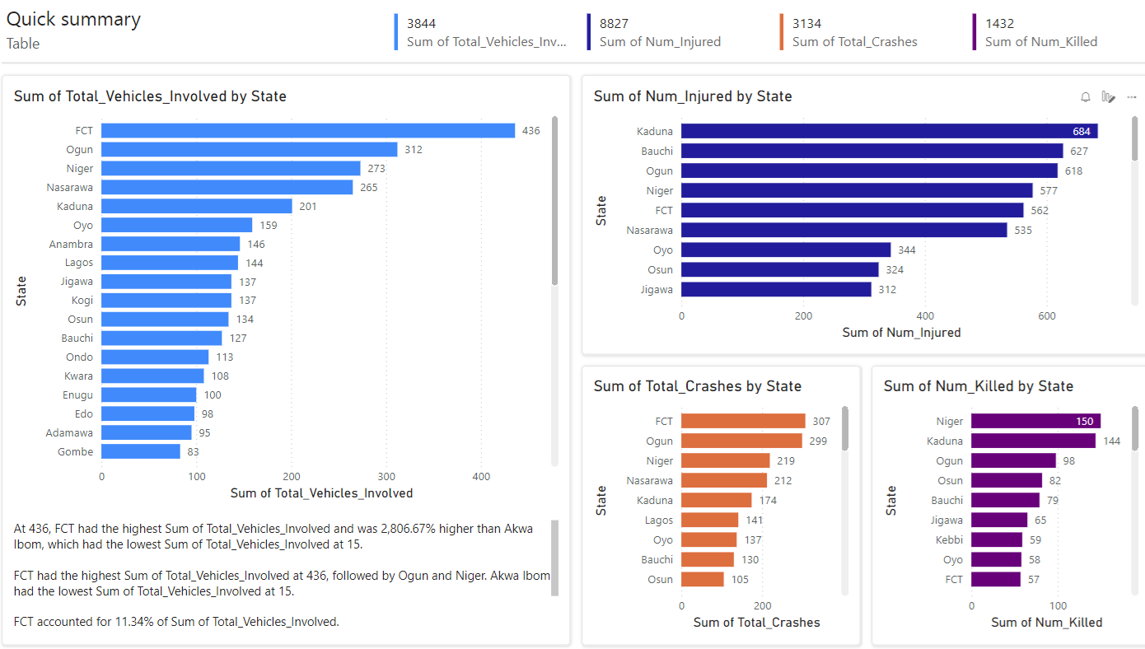

**TableauA:**

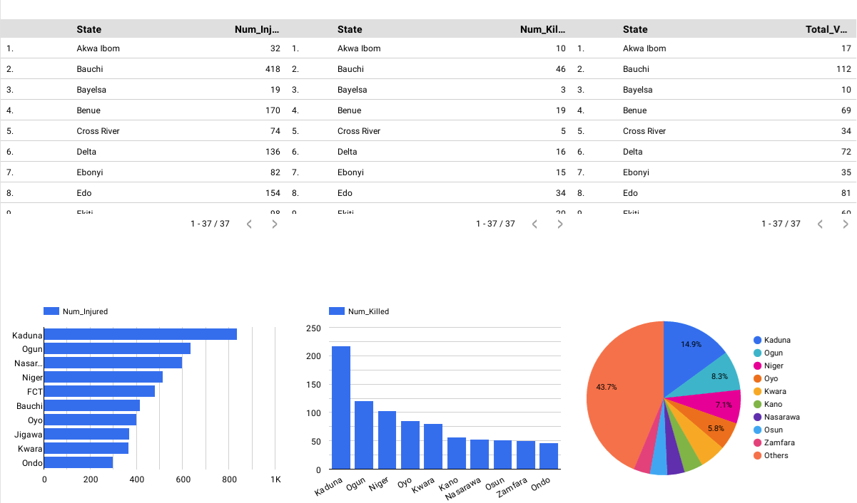

**Google Looker Studio:**

